Lab Exercise 21- Building a Docker Image for an HTML App Using Nginx

1. Setup
You will need:
- Docker installed on your machine.
- A simple HTML file for the app.
2. Step 1: Create the HTML File
Create a directory for your HTML app and place an index.html file in it.
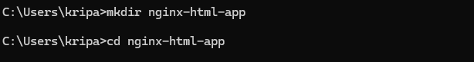
Inside the nginx-html-app directory, create the HTML file.
Edit the index.html file with the following content (or any custom HTML content you want):
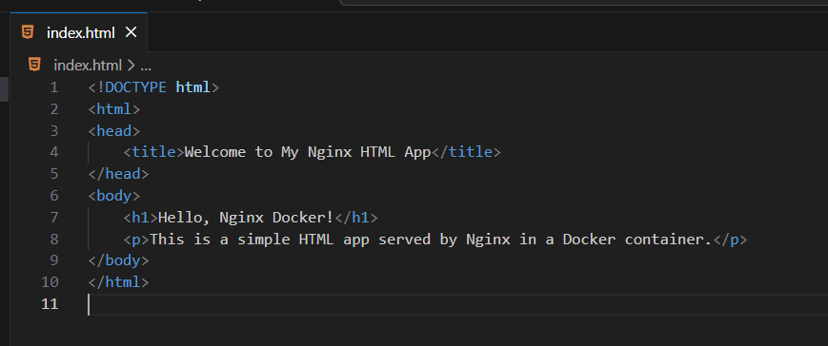

3. Step 2: Create a Dockerfile
In the same directory, create a Dockerfile. This file will define how to build the Docker image using Nginx as the base image.
touch Dockerfile
Edit the Dockerfile and add the following content:
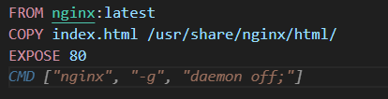
4. Step 3: Build the Docker Image
Now that you have the Dockerfile and index.html, it’s time to build the Docker image.
Run the following command to build the image, giving it a tag (e.g., nginx-html-app):
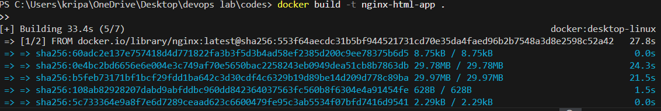
Docker will use the Nginx base image, copy your index.html into the appropriate directory, and build the image.

5. Step 4: Run the Docker Container
After building the image, you can run the container with the following command:
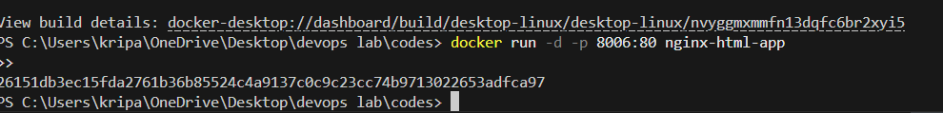
This command runs the container in detached mode (-d) and maps port 8006 on your host machine to port 80 inside the container, where Nginx is serving your HTML app.

6. Step 5: Verify
Open a browser and go to http://localhost:8006. You should see your HTML page with the message “Hello, Nginx Docker!”.
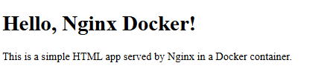

7. Step 6: Stop and Remove the Container
Once you're done, you can stop and remove the container:
